Terraform Task-2

Step 1:
Create 2 EC2 instances on 2 different regions and install nginx using terraform script. create a main.tf file in project folder

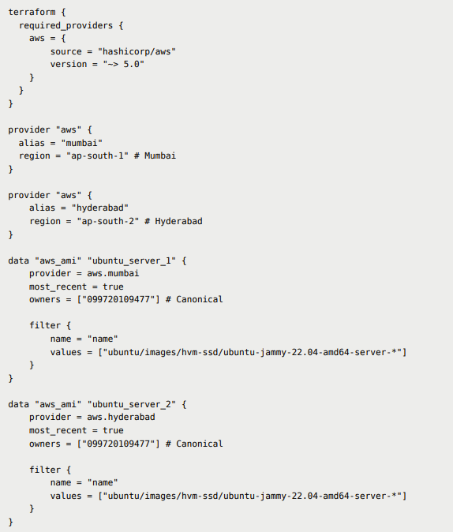
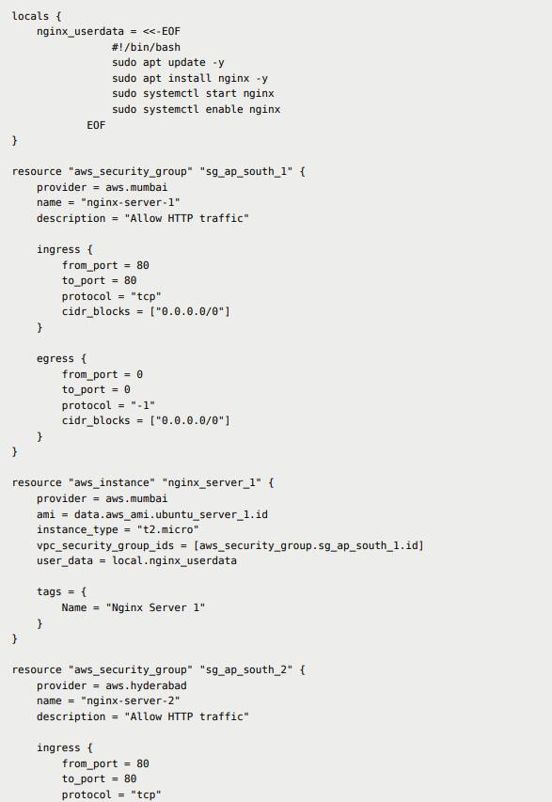
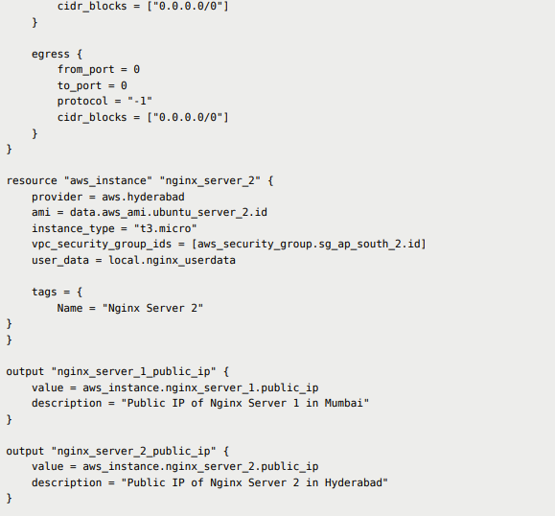

Run

terraform init

terraform plan

terraform apply --auto-approve

terraform destory --auto-approve

